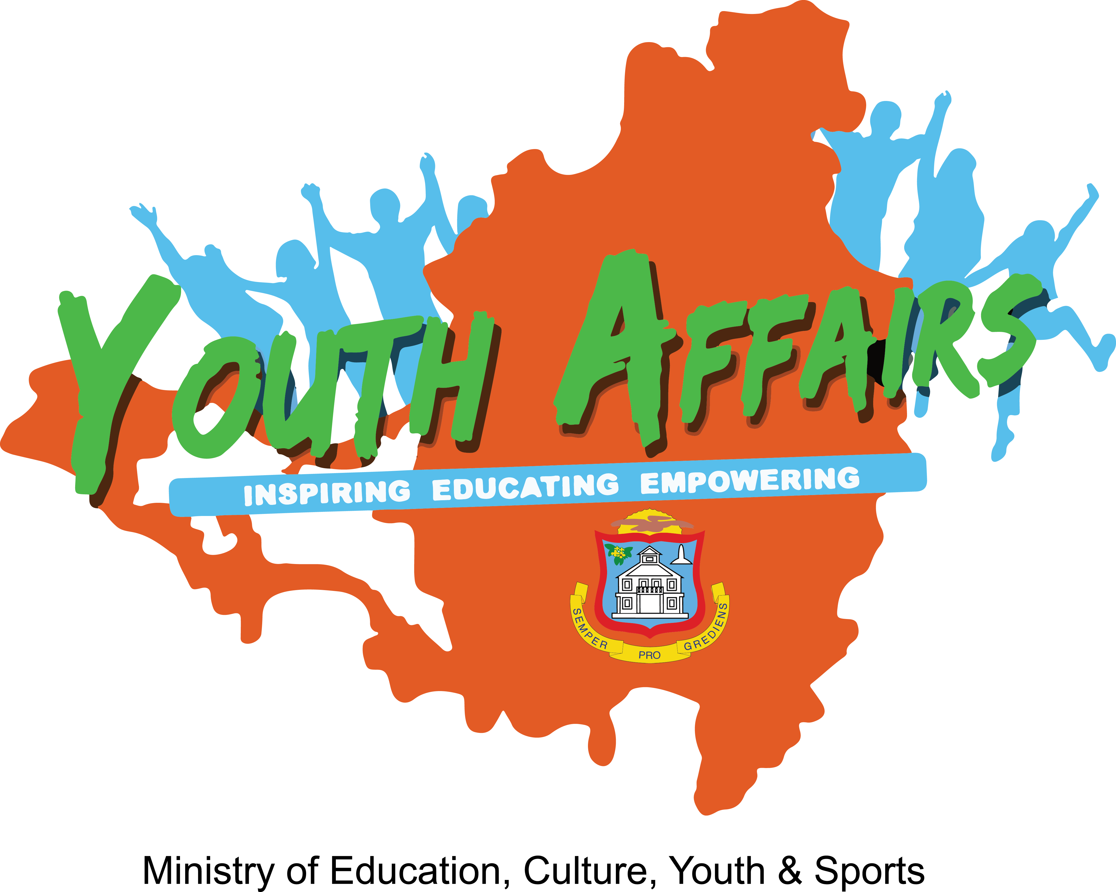

APPLICATION FORM

9th UNESCO Youth Forum
October 26-28, 2015 – Paris, France

The 9th UNESCO Youth Forum will be held at UNESCO Headquarters in Paris, France from 26 to 28 October 2015.

The Forum will take place under the general theme “Young Global Citizens for a Sustainable Planet”, focusing on how young women and men, as global citizens, can contribute to building sustainability, from the global to the local level.
The 9th UNESCO Youth Forum will take place a few weeks after the UN General Assembly would have debated and adopted the new Sustainable Development Goals – SDGs (September 2015) and one month before the 21st Conference of Parties (COP 21) of the United Nations Framework Convention on Climate Change - UNFCCC (30 November – 11 December 2015). This unique moment provides a strategic opportunity for UNESCO to offer a visible platform through which young women and men can voice their opinions that could also feed into the discussion around UNESCO’s future role, in the context of the celebration of the 70th anniversary of the Organization.
Education and skills for sustainable development and employability, diversity and culture of peace, rights and freedoms, and climate change are some of the topics for discussion at the upcoming forum.
The Forum’s outputs will be composed of strategic recommendations and action projects, and will be presented at the 38th session of the General Conference.
See below requirements for persons interested in participating in the 9th UNESCO Youth Forum.

Application Requirements:
- Applicant must be between 18 to 24 years of age
- Applicant must be a national of St. Maarten
  - In possession of a Dutch passport or residence permit for at least 5 years
- Applicant must submit his/her application form by June 8, 2015 at the
St. Maarten Youth Desk / UNESCO Office, or email the application form to: unesco.sx@gmail.com or youthaffairs@sintmaartengov.org.
- Applicant must submit a copy of their valid passport and/or residence permit
- Applicant must submit curriculum vitae
- A letter of motivation
- Two (2) Reference letters: one from a recognized youth-related or youth focused NGO and the other from their school or employer.
- Official note from the NGO stating its vision, mission, scope and activities
- Documentation showing experience in project management
- Applicant need to have proficient communication and writing skills
- Applicant need to be available to share knowledge acquired from the youth forum, which can be used towards the policy development within the Department of Youth Affairs

Please note: You will have to participate in a mandatory interview and debate.

For further information, contact Ms. Marcellia Henry (Cel# 5203051) or Ms. Faye Arnell (Tel # 5422056).

Kindly complete all sections of this application form.

A. PERSONAL DATA
Family Name: | Sex: □ Male □ Female
First Name: | Date of Birth (date/month/year) :
Maiden Name (if any): | Place of Birth:
Middle Name: | Nationality:
Telephone: | Email Address:
Occupation: □ Student □ Employed

B. LANGUAGES

Please include all languages spoken.

LANGUAGES | READ |  | WRITE |  | SPEAK |  | UNDERSTAND
 | Basic | Fluent | Basic | Fluent | Basic | Fluent | Basic | Fluent

C. LIST RELEVANT GROUPS/ORGANIZATIONTS THAT YOU ARE A MEMBER OF
NAME | ADDRESS | CONTACT/EMAIL

D. OVERVIEW OF YOUR QUALIFICATIONS/EXPERIENCE (200 WORDS).

E. COMMUNITY INVOLVEMENT/PARTICIPATION (200 WORDS)

F. MOTIVATIONAL LETTER (500 Words)

Please explain:
- Why you want to be a part of this forum, what you hope to achieve and how you intend to use the knowledge/experience gained.
- Why do you think you should qualify to represent the youth of St. Maarten?

