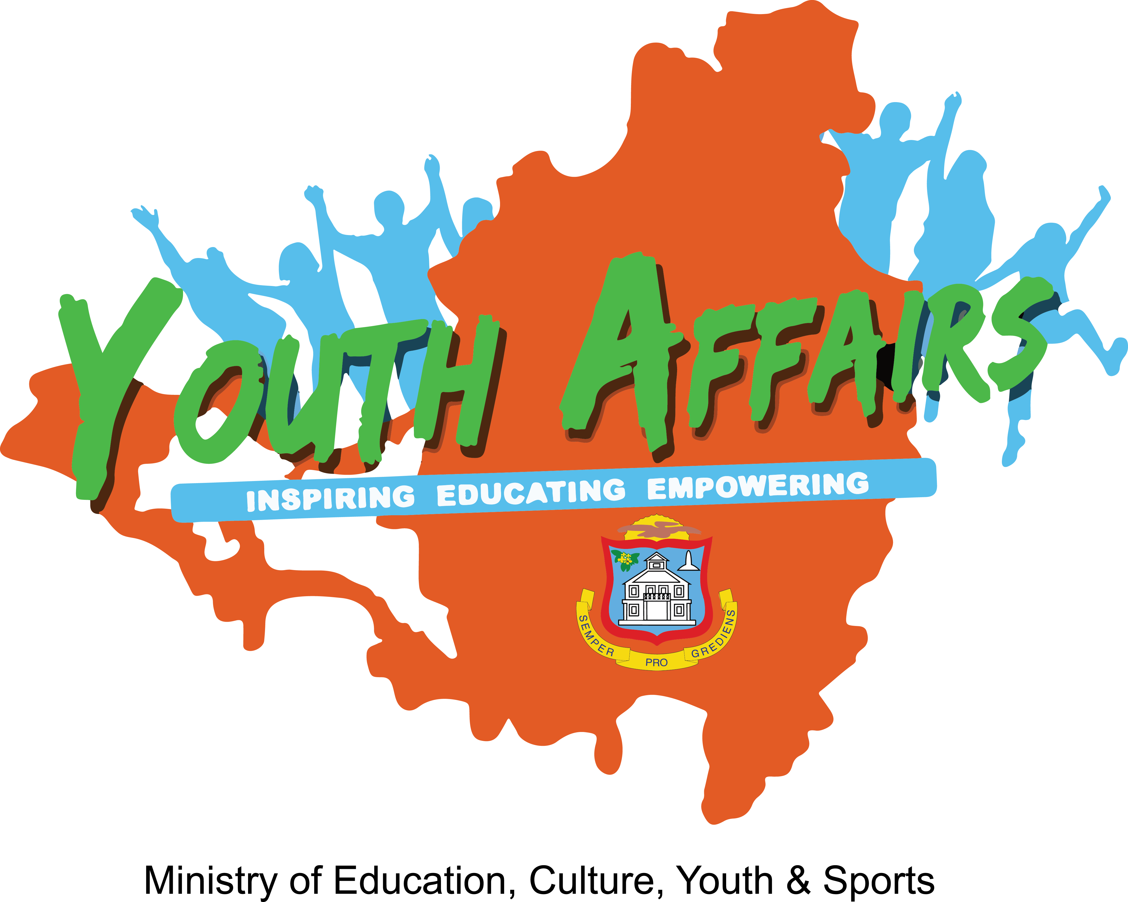

APPLICATION FORM

10th UNESCO Youth Forum
October 25-26, 2017 – Paris, France

The 10th UNESCO Youth Forum will be held at UNESCO Headquarters in Paris, France from 25 to 26 October 2017.

Since 1999, the UNESCO Youth Forum have provided an innovative, ongoing opportunity for youth to work in dialogue with UNESCO, to shape and direct the Organization’s approach and to present their concerns and ideas to Member States.
The forum brings together expert youth from all regions of the world to discuss pertinent issues related to UNESCO fields of competence. During the youth forum, a series of recommended actions and priorities will be drafted to guide UNESCO’s youth actions for the next biennium. These will be presented at the 39th Session of the UNESCO General Conference.
See below requirements for persons interested in participating in the 10th UNESCO Youth Forum.

Application Requirements:
- Applicant must be between 18 to 24 years of age
- Applicant must be a national of St. Maarten
  - In possession of a Dutch passport or residence permit for at least 5 years
  - Passport need to be valid for at least a year at the time of travel commencement date
- Applicant must submit his/her application form by June 9, 2017 at the
Youth Department or UNESCO Office, or email the application form to: unesco.sx@gmail.com or youthaffairs@sintmaartengov.org
- Applicant must submit a copy of their valid passport and/or residence permit
- Applicant must submit curriculum vitae
- A letter of motivation
- Two (2) Reference letters: one from a recognized youth-related or youth focused NGO and the other from their school or employer.
- Official note from the NGO stating its vision, mission, scope and activities
- Documentation showing experience in project management
- Applicant need to have proficient communication, writing and debating skills
- Applicant need to be available to share knowledge acquired from the youth forum, which can be used towards the policy development within the Department of Youth Affairs

Please note: You will have to participate in a mandatory interview and debate.

For further information, contact Ms. Marcellia Henry (Cel# 5203051) or Ms. Faye Arnell (Tel # 5422056).

Kindly complete all sections of this application form.

A. PERSONAL DATA
Family Name: | Sex: □ Male □ Female
First Name: | Date of Birth (date/month/year) :
Maiden Name (if any): | Place of Birth:
Middle Name: | Nationality:
Telephone: | Email Address:
Occupation: □ Student □ Employed

B. LANGUAGES

Please include all languages spoken.

LANGUAGES | READ |  | WRITE |  | SPEAK |  | UNDERSTAND
 | Basic | Fluent | Basic | Fluent | Basic | Fluent | Basic | Fluent
C. LIST RELEVANT GROUPS/ORGANIZATIONTS THAT YOU ARE A MEMBER OF
NAME | ADDRESS | CONTACT/EMAIL

D. OVERVIEW OF YOUR QUALIFICATIONS/EXPERIENCE (200 WORDS).

E. COMMUNITY INVOLVEMENT/PARTICIPATION (200 WORDS)

F. MOTIVATIONAL LETTER (500 Words)

Please explain:
- Why you want to be a part of this forum, what you hope to achieve and how you intend to use the knowledge/experience gained.
- Why do you think you should qualify to represent the youth of St. Maarten?

